OOPS

what is oops?

Object Oriented Programming System is a mechanism to write program using class and object.

Under OOPS we have 4 Principles -- OOAD

1) Abstraction : it is a process of getting required data and hiding other.

2) Encapsulation : It is Process of binding variables and methods in a class.

Q) What is a class ?

A) Class is a collection of variables and methods.

syntax

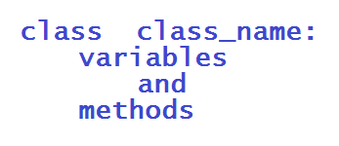

Instance and Static Variables

|  |  |
| --- | --- |
| **Instance** | **Static** |
| The variables which are declared using **"self"** parameter are called as Instance variables | The variables which are declared inside the class and outside the method are called as static |
| Instance variables will get memory for every object creation | Static variables will get memory only 1 time |
| To call instance variables we use object or object reference variable. | To call static variables we use class name.  Ex: Class_name . Variable_name |
|  | We can access static variables anywhere but using class name. |

Instance and static Methods

|  |  |
| --- | --- |
| **Instance** | **Static** |
| Instance variables will perform operation on instance variables | Static method will perform operation on static variables |
| Instance method will take **"self"** as a parameter | To declare static method we use **"@staticmethod"** decorator. |
| To call instance methods we use object or object reference variable | To call static methods we use class name |

**Note :** If you want to access instance variables or instance methods within the same class we use **"self"** parameter.

**What is Object ?**

Object is an instance of a class.

**Syntax :**

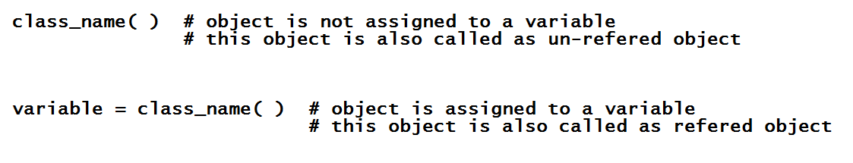

**What is Instance ?**

Instance me allocating memory for instance variables.

**How many objects we can create to a single class?**

One class can have any number of objects.

**Constructor**

Constructor is a special kind of method because the constructor name must be "__init__" only.

No need to call constructor manually because it called automatically at the time of object creation.

Constructor is used to initialize instance variables of a class.

Constructor is called 1 time for 1 object, it means if we create 10 Objects the constructor is called 10 times automatically.

These kind of methods are also called as Dunder (Double Underscore) Methods or Magic Methods.

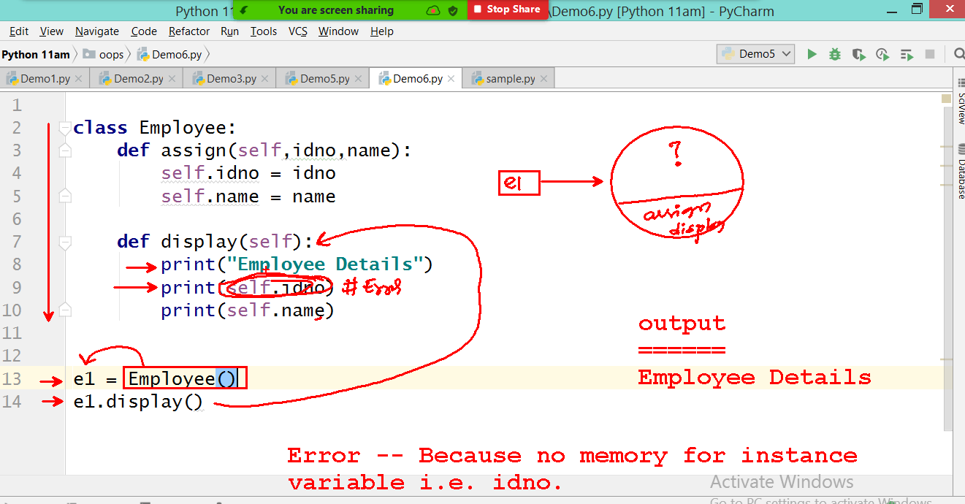

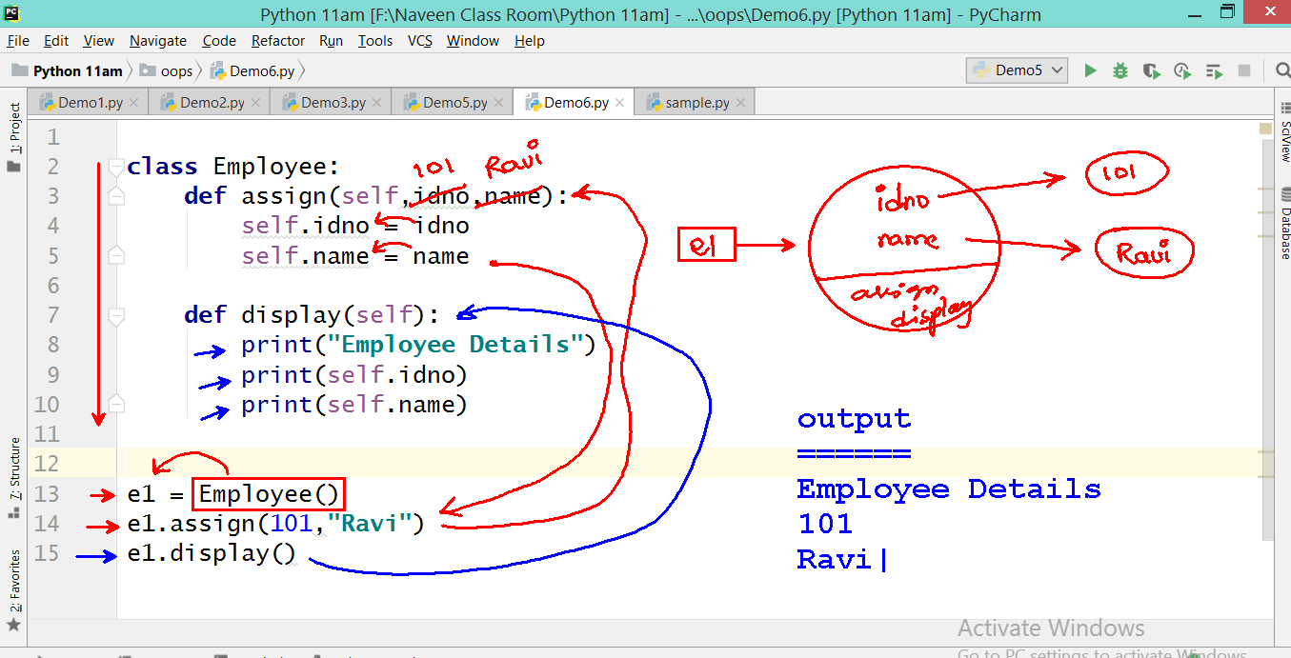

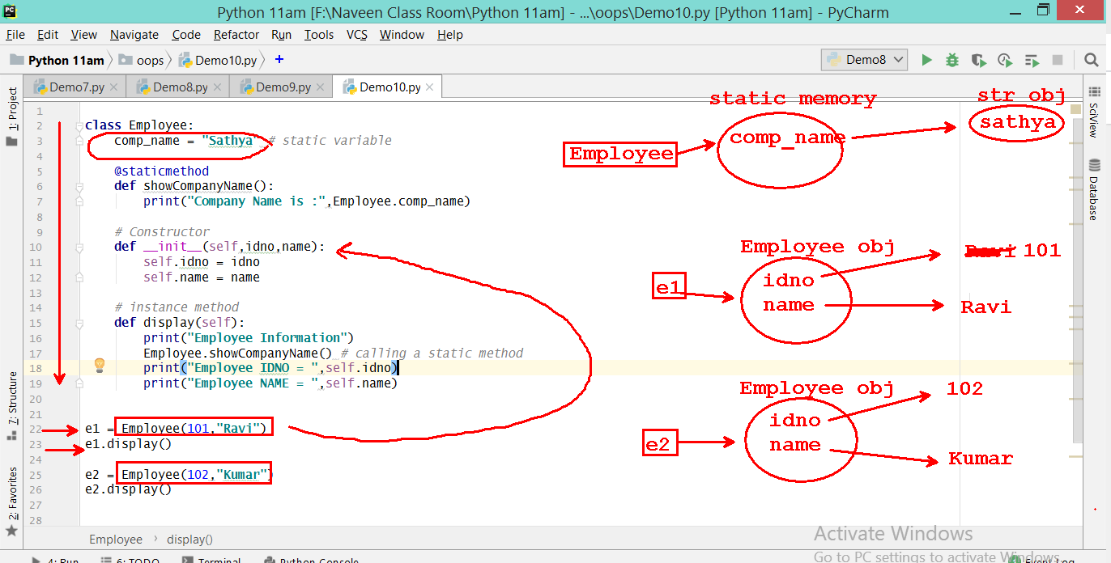

Difference between referred and un referred object.

1) Referred Object

Using referred object we can call multiple methods for multiple times.

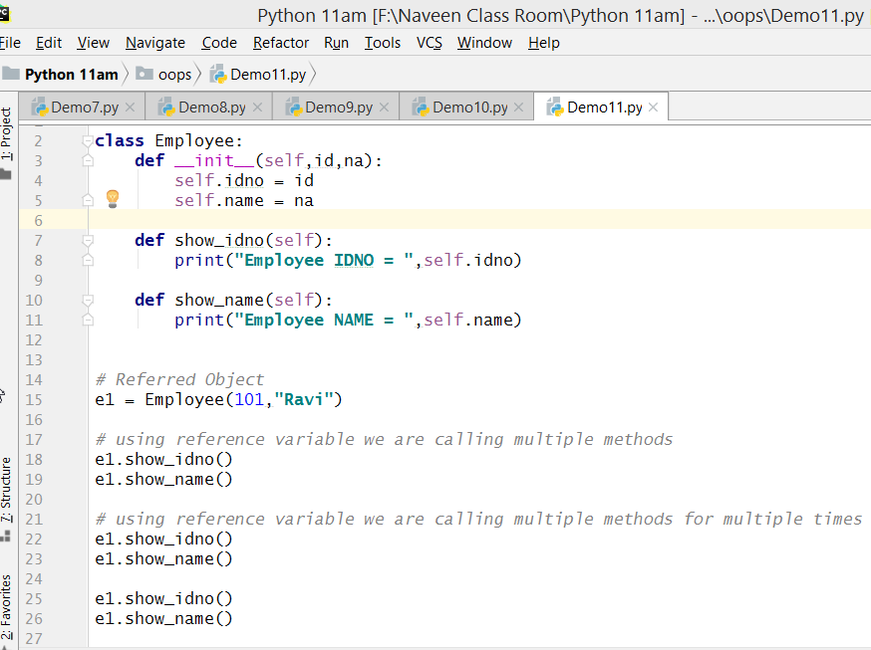

2) Un referred Object

Using un referred object we can call only 1 method for 1 time.

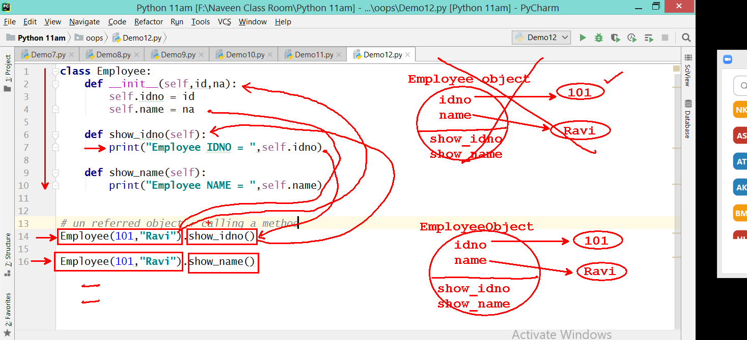

**"self".**

self is a default parameter in instance method or constructor.

The "self" word can be re-named.

self represents current object.

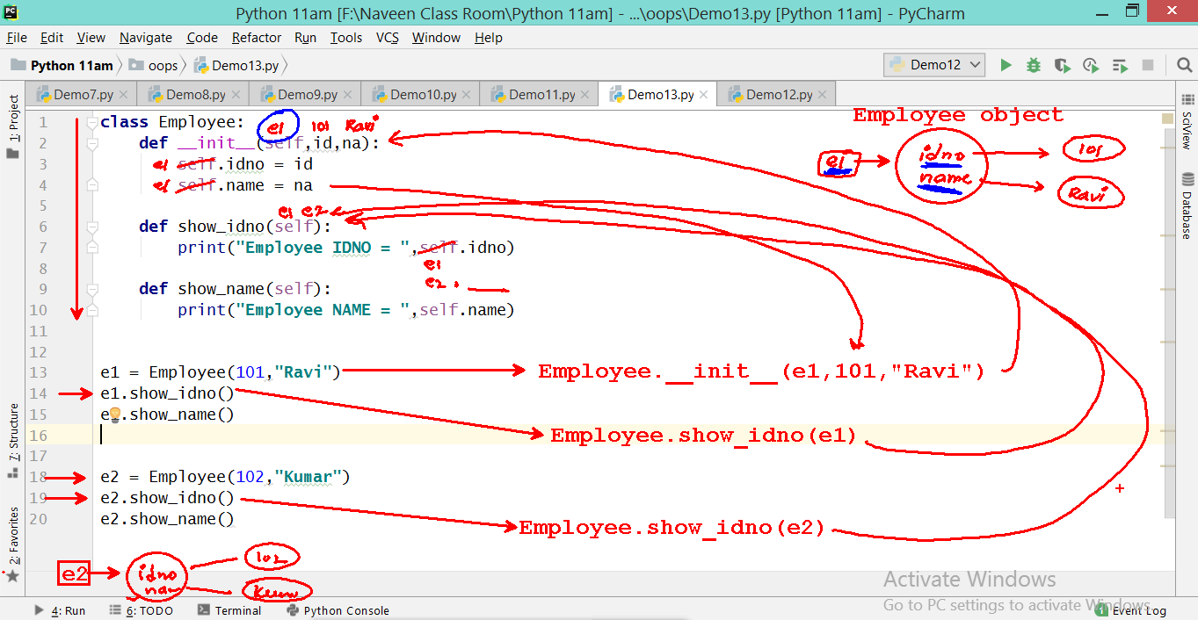

3) Inheritance

4) Polymorphism